Mirror Rhyme (less common)

🔄 What is Mirror Rhyme (less common)
# Source: AI Source: Provided by: [Data Path: Persons Table -> ID Column: 1, Name_En Column: Motasem Essam] -> From: [Chatgpt (GPT-4-turbo)] on [8/2/2025]
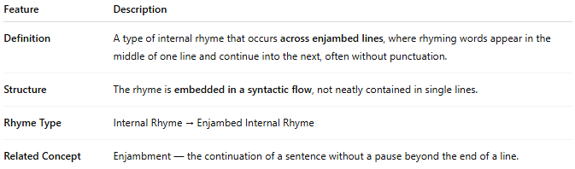
Feature | Description
Definition | A rare form of internal rhyme where words within the same line (or across two lines) are reversed or reflected in sound or structure, giving a mirrored phonetic effect.
Structure | Often involves palindromic or near-palindromic sound patterns or visual symmetry between rhyming words.
Rhyme Type | Internal Rhyme → Mirror Rhyme (special form)
Also Called | Palindromic rhyme (in some extended definitions)

📝 Examples (Phonetic Mirror or Word Reversal Style):
# Source: AI Source: Provided by: [Data Path: Persons Table -> ID Column: 1, Name_En Column: Motasem Essam] -> From: [Chatgpt (GPT-4-turbo)] on [8/2/2025]
He faced the trap, then sprang the part.
The demon's loop spun into a pool of fear.
A fleeting snap became a bitter pan of regret.
Here, trap–part, loop–pool, and snap–pan share mirrored or reversed sounds—not exact rhymes, but reflective in construction, hence the "mirror" quality.

🎭 Effect in Poetry:
# Source: AI Source: Provided by: [Data Path: Persons Table -> ID Column: 1, Name_En Column: Motasem Essam] -> From: [Chatgpt (GPT-4-turbo)] on [8/2/2025]
- Creates a sense of duality, reflection, or reversal
- Useful for poems with themes of mirrors, opposites, or internal struggle
- Adds subtle texture and sonic symmetry to internal structure
- May evoke unease or cleverness, depending on context

✅ When to Use:
# Source: AI Source: Provided by: [Data Path: Persons Table -> ID Column: 1, Name_En Column: Motasem Essam] -> From: [Chatgpt (GPT-4-turbo)] on [8/2/2025]
- To support thematic content about identity, reversal, reflection
- In experimental poetry, puzzles, or wordplay-based writing
- When you want to surprise the reader with uncommon sonic echoes

